Armenia: Macroeconomic Report

# GDP growth in 2019 rose

GDP growth rose by 7.6% year-on-year (yoy) in 2019. On the demand side, private consumption (83.4% of GDP) contributed the most to growth, with 9.3 percentage points (pp). On the supply side, services (54.2% of GDP) contributed the most to growth, with 5.4pp.

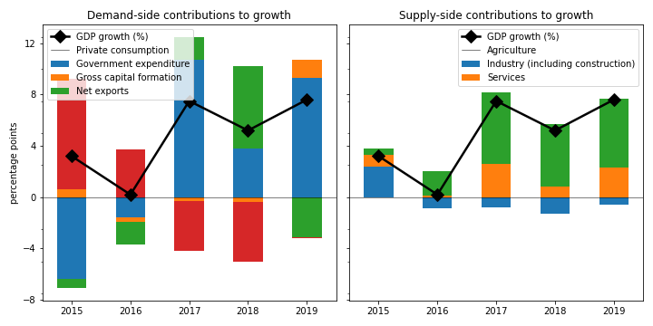

## Government expenditure increased the fastest on the demand side

Government expenditure increased by the largest margin (12.5%). Private consumption grew by 11.7%. Net exports jumped by 7.1%. On the other hand, gross capital formation plunged by 13.8%.

## On the supply side, services increased the fastest

Services increased the most rapidly (10.3%). Industry (including construction) picked up by 9.1%. On the other hand, agriculture contracted by 4.0%.

## Unemployment improved; inflation declined

Unemployment improved from 19.0% in 2018 to 18.3% in 2019, while inflation declined from 2.5% to 1.4%. At the end of 2020, the central bank set the policy rate at 5.3%.

## Current account balance deficit

The current account balance (CAB) recorded a deficit at 7.2% of GDP in 2019, compared to 6.9% in 2018.

Russian Federation is the top export destination (27.2% of exports in 2019). Other major exports partners include Switzerland (17.5%), Bulgaria (7.9%), and China (7.4%). Top export products are ores, slag and ash (25.5% of exports).

Top imports origins are Russian Federation (29.2%), China (14.7%), Iran (6.4%), and Turkey (5.3%). Major import commodities are mineral fuels, mineral oils and products of their distillation; bituminous substances; mineral waxes(15.1% of imports).

# Output contracted in Q3 2020

Output plunged by 9.1% yoy in Q3 2020 (-13.7% in the previous quarter). Exports slowed down by the largest margin at -44.7% yoy. Gross capital formation contracted by 11.4%.

## Leading indicators

Retail sales shrank by 21.6% yoy in December (-17.1% yoy in November).

## Inflation picked up

Inflation rose to 3.9% yoy in December (1.8% yoy in November). Meanwhile, the central bank tightened the policy rate to 5.5% in February (5.3% in January).

# Outlook favorable this year

As of January 2021, Consensus Economics panelists project economic growth ending at 5.0% in 2021, while in 2022, the panelists foresee growth at 5.5%. Industrial production is seen to change by 5.8% and 6.2%. Finally, Consensus Economics foresee inflation at 1.9% in 2021 and 3.4% in 2022.

*Sources: Consensus Economics, The World Bank, UN Comtrade, Haver Analytics, and National Sources. Accessed 23 February 2021.*